### Admin Side Epic (Coupon Management by Admin)

As an Admin/Marketing Team,  
I want to create and manage coupons,  
So that I can run promotional campaigns effectively.

**To-Be Process Flow**

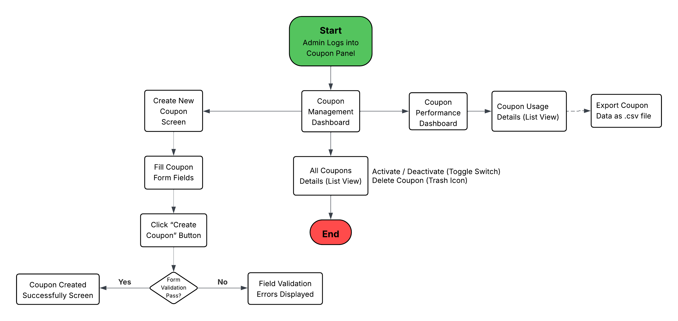

**US-01: Coupon Management Dashboard**

|  |  |
| --- | --- |
| **As an** | admin |
| **I want** | to view and manage all existing coupons in a centralized dashboard |
| **So that** | I can easily monitor, activate/deactivate, and delete coupons when needed. |
| **Acceptance Criteria** | 1. Admin logs into the Coupon Management Panel from the Admin Dashboard. 2. System displays the Coupon List View, showing all created coupons in a list view format (Pagination/scrollbar will be present if the coupon list exceeds visible rows). (Refer Appendix 1) 3. Admin can Search Coupons using a Search Bar or a Dropdown. 4. Admin can Activate/Deactivate Coupons directly by toggling the status switch in the list. 5. Admin can Delete a Coupon by clicking the Delete Icon. System prompts a confirmation popup before deletion. 6. Admin can click on ‘Create New Coupon’ Button to navigate to Coupon Creation Form. (Refer Appendix 2) 7. Admin can click on ‘Coupon Performance’ Button to navigate to Coupon Performance Dashboard. (Refer Appendix 3) |

**Appendix 1**

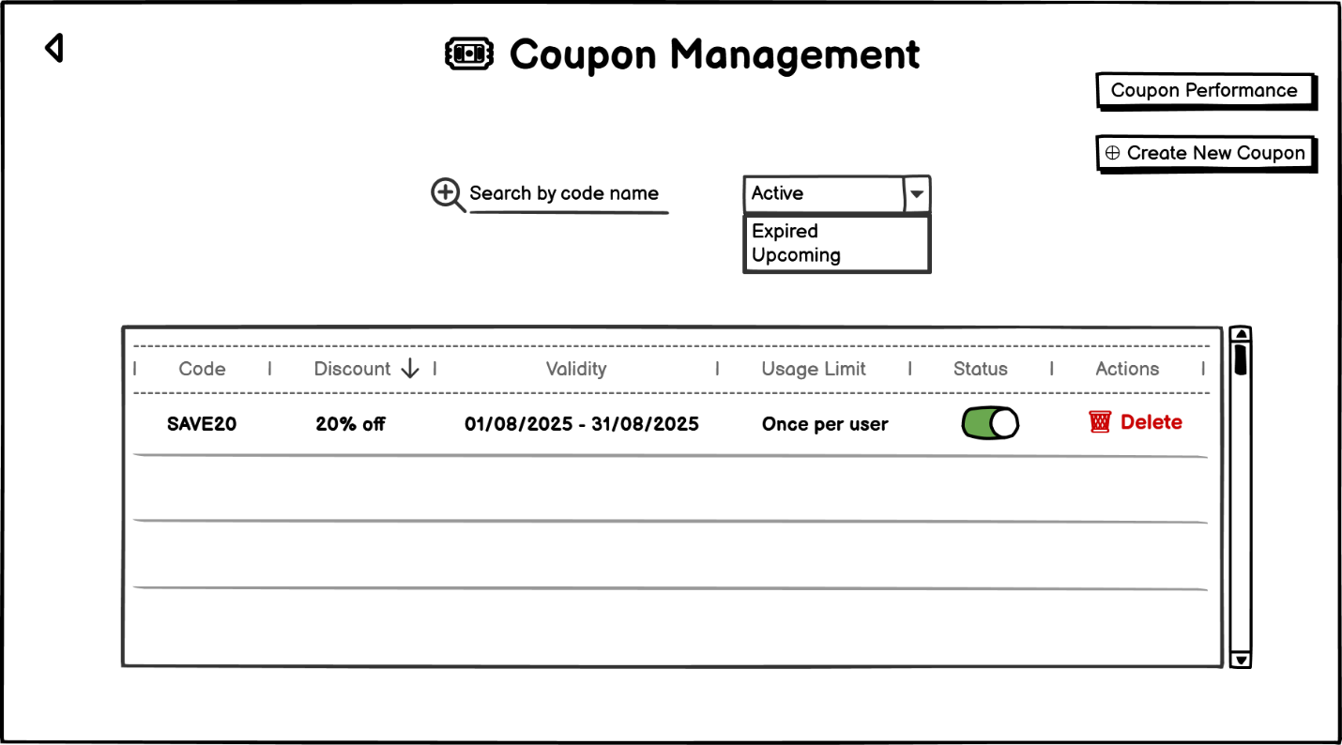

|  |  |  |  |  |  |  |  |
| --- | --- | --- | --- | --- | --- | --- | --- |
| **Sr. No.** | **Field Name** | **Field Type** | **Content** | **Required Field?** | **Min. Char.** | **Max Char.** | **Notes** |
| 1 | Page Title | Label / Heading | Coupon Management | N/A | N/A | N/A | Displayed at the top-center of the admin panel page |
| 2 | Search Bar | Text Input + Icon | Alpha-Numeric | No | 3 | 30 | Helps admin search for specific coupon codes |
| 3 | Status Filter Dropdown | Dropdown Select | Active, Expired, Upcoming | No | N/A | N/A | Used to filter coupon records based on status |
| 4 | Coupon Performance Button | Command Button | Coupon Performance | No | N/A | N/A | Navigates to ‘Coupon Performance’ page |
| 5 | Create New Coupon Button | Command Button | ➕ Create New Coupon | No | N/A | N/A | Navigates to ‘Create New Coupon’ page |
| 6 | Coupon Table | Data Table | Code, Discount, Valid Dates, etc. | N/A | N/A | N/A | Displays all coupon data in a tabular format |
| 7 | Code | Table Column | SAVE20 | N/A | N/A | N/A | Unique alphanumeric identifier for the coupon |
| 8 | Discount | Table Column | 20% off | N/A | N/A | N/A | Type of discount applicable |
| 9 | Validity | Table Column | 01/08/2025 – 31/08/2025 | N/A | N/A | N/A | Duration in which the coupon is valid |
| 10 | Usage Limit | Table Column | Once per user | N/A | N/A | N/A | Restriction on number of times a user can redeem the coupon |
| 11 | Status Toggle | Switch | Toggle ON/OFF | No | N/A | N/A | Allows admin to activate/deactivate a coupon |
| 12 | Delete Coupon | Command Link/Button | 🗑️ Delete | No | N/A | N/A | Allows admin to permanently delete a coupon |
| 13 | Scrollbar | Scroll Component | Vertical scrollbar | N/A | N/A | N/A | Allows scrolling if coupon list exceeds visible area |
| 14 | Back Button | Command Button | ← | No | N/A | N/A | Navigates back to previous screen |

**US-02: Create New Coupon**

|  |  |
| --- | --- |
| **As an** | admin |
| **I want** | to create new coupon codes |
| **So that** | I can offer discounts to customers. |
| **Acceptance Criteria** | 1. Admin logs into the **Coupon Management Panel** from the Admin Dashboard. 2. Admin clicks on the ‘**Create New Coupon’** button. 3. System navigates to the **Create New Coupon Form Screen**. (Refer Appendix 2) 4. Admin fills in all the mandatory fields. Admin can also choose to activate the coupon directly while creating it. 5. Admin clicks on the ‘**Create Coupon’** button. 6. System performs validations:   If validations pass -  Coupon is created successfully.  System navigates to the **Coupon Created Successfully** screen. (Refer Appendix 3)  Admin is given options to **Return to Dashboard** or **Create Another Coupon**.  If validations fail -  System displays **inline field-level error messages**.  Admin remains on the **Create Coupon Form screen** for correction. |

**Appendix 2**

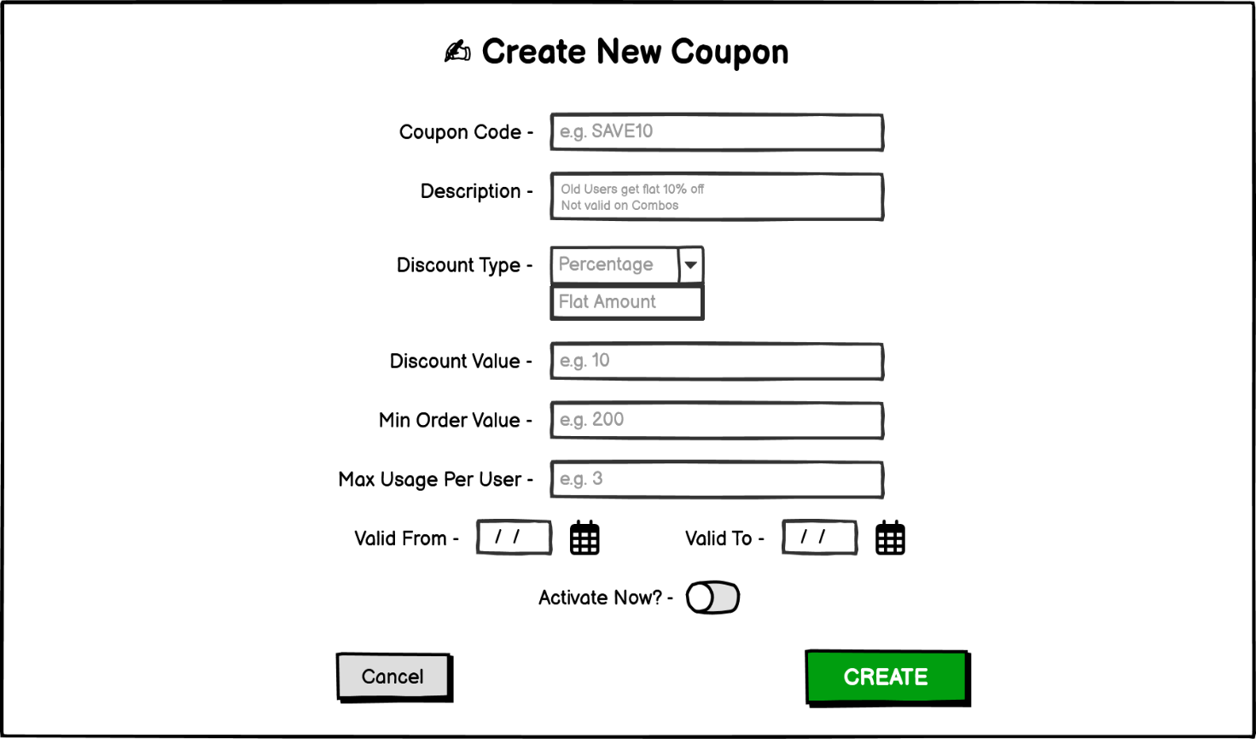

|  |  |  |  |  |  |  |  |
| --- | --- | --- | --- | --- | --- | --- | --- |
| **Sr. No.** | **Field Name** | **Field Type** | **Content** | **Required Field?** | **Min. Char.** | **Max Char.** | **Notes** |
| 1 | Page Title | Label / Heading | Create New Coupon | N/A | N/A | N/A | Main heading at the top of the page |
| 2 | Coupon Code | Text Input | Alpha-Numeric | Yes | 3 | 20 | Unique code identifier entered by admin |
| 3 | Description | Text Area | Alpha-Numeric | No | 10 | 200 | Optional coupon description with rule or condition |
| 4 | Discount Type | Dropdown | Percentage, Flat Amount | Yes | N/A | N/A | Admin must select one type of discount |
| 5 | Discount Value | Text Input | Numeric | Yes | 1 | 3 | Numeric value, interpreted based on discount type |
| 6 | Min Order Value | Text Input | Numeric | Yes | 0 | 4 | Minimum cart amount for coupon to be applicable |
| 7 | Max Usage Per User | Text Input | Numeric | Yes | 1 | N/A | Max times a user can apply this coupon |
| 8 | Valid From | Date Picker | [Calendar icon] | Yes | N/A | N/A | Start date of coupon validity |
| 9 | Valid To | Date Picker | [Calendar icon] | Yes | N/A | N/A | End date of coupon validity |
| 10 | Activate Now? | Toggle Switch | On / Off | No | N/A | N/A | Optional toggle to activate the coupon immediately |
| 11 | Create Button | Command Button | CREATE | Yes | N/A | N/A | Navigates to ‘Coupon Created Successfully’ page |
| 12 | Cancel Button | Command Button | Cancel | No | N/A | N/A | Navigates to ‘Coupon Management (Admin)’ page without saving |

**‘Create New Coupon’ data validations**

On click of **‘Create’** command button, the system shall perform the following validations:

* All required fields are filled
* Coupon code is alphanumeric (no special characters)
* Discount type is selected (Percentage or Flat Amount)
* Discount value is a positive number
* Min Order Value is a positive number (0 accepted)
* Max Usage per User is a valid non-zero number
* Valid From and Valid To dates are selected and are in the correct chronological order

‘Create New Coupon’ page data validation = Pass

In the event of **passing** all validations, the system shall:

* Save the coupon
* Navigate the admin to the **‘Coupon Created Successfully’** page, showing all entered values and confirmation of coupon creation.

6.7.2.2 ‘Create New Coupon’ page data validation = Fail

In the event of **failure** of one or more validations, system shall display relevant error messages as per the table below:

**Error Messages:**

|  |  |
| --- | --- |
| **Failed Validation** | **Error Message Displayed** |
| Required field missing | <Field Name> is a required field. Please enter a value. |
| Invalid coupon code format | Coupon Code is invalid. Use alphanumeric characters only. |
| Discount type not selected | Please select a discount type. |
| Discount value is not a valid number | Discount Value must be a positive number. |
| Min Order Value is invalid (if required) | Min Order Value must be a valid number. |
| Max Usage Per User is not valid | Max Usage must be a non-zero positive number. |
| Invalid or missing date range | Select valid ‘Valid From’ and ‘Valid To’ dates. |
| Valid From is after Valid To | Valid From date cannot be after Valid To date. |

**Appendix 3**

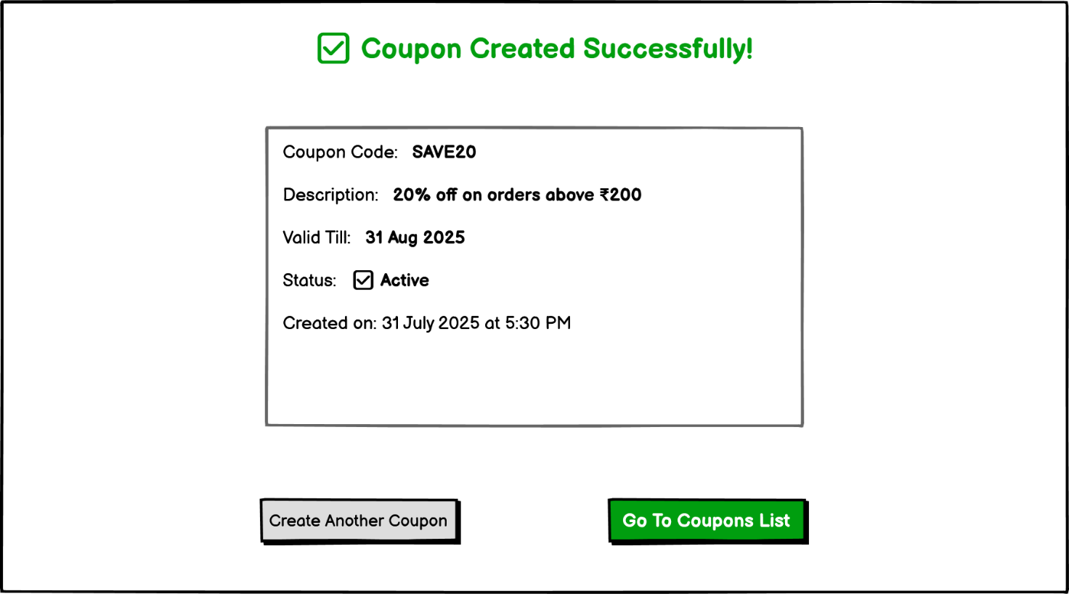

|  |  |  |  |  |  |  |  |
| --- | --- | --- | --- | --- | --- | --- | --- |
| **Sr. No.** | **Field Name** | **Field Type** | **Content** | **Required Field?** | **Min. Char.** | **Max Char.** | **Notes** |
| 1 | Confirmation Message | Label / Heading | ✅ Coupon Created Successfully! | N/A | N/A | N/A | Displayed in green at the top-center |
| 2 | Coupon Code | Text Label | Coupon Code: SAVE20 | N/A | N/A | N/A | Shows the code of the newly created coupon |
| 3 | Description | Text Label | Description: 20% off on orders above ₹200 | N/A | N/A | N/A | Description shown as entered in form |
| 4 | Valid Till | Text Label | Valid Till: 31 Aug 2025 | N/A | N/A | N/A | End date of coupon validity |
| 5 | Status | Text Label | Status: ✅ Active | N/A | N/A | N/A | Shows the current status of coupon |
| 6 | Created On | Text Label | Created on: 31 July 2025 at 5:30 PM | N/A | N/A | N/A | Timestamp showing coupon creation |
| 7 | Create Another Coupon | Command Button | Create Another Coupon | No | N/A | N/A | Navigates to ‘Create New Coupon’ page |
| 8 | Go To Coupons List | Command Button | Go To Coupons List | No | N/A | N/A | Navigates to ‘Coupon Management (Admin)’ page |

**US-03: View Coupon Performance Dashboard**

|  |  |
| --- | --- |
| **As an** | admin |
| **I want** | to view analytics and performance metrics for all coupons |
| **So that** | I can assess the effectiveness of promotional campaigns and take necessary actions. |
| **Acceptance Criteria** | |  | | --- | | 1. Admin logs into the **Coupon Management Panel** from the Admin Dashboard. 2. Admin clicks on ‘Coupon Performance’ Button. 3. System navigates to the ‘**Coupon Performance Dashboard’**. (Refer Appendix 4) 4. System displays **overall statistics cards** at the top. 5. Below the summary cards, a detailed **Coupon Performance Table** is displayed listing all coupons with their usage details. The coupon usage details should reflect **live data synced from usage logs**. (Pagination/scrollbar will be present if the coupon list exceeds visible rows). 6. Admin can **Search Coupons** using a Search Bar or a Dropdown. If no data matches the search/filter, system should display “No Coupons Found” message. 7. Admin can **Export the Performance Report** in CSV/Excel format. | |

**Appendix 4**

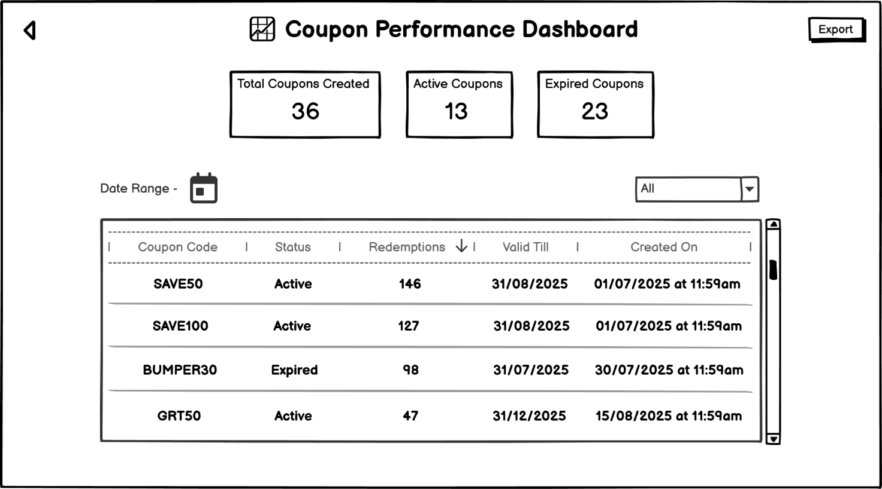

|  |  |  |  |  |  |  |  |
| --- | --- | --- | --- | --- | --- | --- | --- |
| **Sr. No.** | **Field Name** | **Field Type** | **Content** | **Required Field?** | **Min. Char.** | **Max Char.** | **Notes** |
| 1 | Page Title | Label / Heading | Coupon Performance Dashboard | N/A | N/A | N/A | Appears at the top to indicate current admin section |
| 2 | Export Button | Command Button | Export | No | N/A | N/A | Allows exporting data in CSV/Excel format |
| 3 | Total Coupons Created | Stat Display Card | Total Coupons Created – 36 | N/A | N/A | N/A | Displays the total number of coupons added till now |
| 4 | Active Coupons | Stat Display Card | Active Coupons – 13 | N/A | N/A | N/A | Displays number of currently active coupons |
| 5 | Expired Coupons | Stat Display Card | Expired Coupons – 23 | N/A | N/A | N/A | Displays number of expired coupons |
| 6 | Date Range Picker | Date Input | [Calendar Icon] | No | N/A | N/A | Used to filter coupons based on selected date range |
| 7 | Status Filter Dropdown | Dropdown | All / Active / Expired | No | N/A | N/A | Dropdown to filter coupons based on the current status |
| 8 | Coupon Code | Table Column | SAVE50, SAVE100, BUMPER30, GRT50 | N/A | N/A | N/A | Displays coupon codes in list view |
| 9 | Status | Table Column | Active / Expired | N/A | N/A | N/A | Shows current state of coupons |
| 10 | Redemptions Count | Table Column | 146, 127, 98, 47 | N/A | N/A | N/A | Number of times each coupon has been used |
| 11 | Valid Till Date | Table Column | e.g., 31/08/2025 | N/A | N/A | N/A | End date of coupon validity |
| 12 | Created On Date & Time | Table Column | e.g., 01/07/2025 at 11:59am | N/A | N/A | N/A | Timestamp when coupon was created |
| 13 | Scrollbar | UI Control | Vertical Scrollbar | N/A | N/A | N/A | Allows scrolling through the list of coupons |
| 14 | Back Button | Command Button | ← | No | N/A | N/A | Navigates back to previous screen |